

**Java Institute for Advanced Technology**

**UNIT NAME: -** SOFTWARE APPLICATION DEVELOPMENT

**UNIT ID: -** H7E1



**NAME: - Tuwan Munaff Adahan**

**SCN NO: -** 207981850

**NIC: - 199627703028**

**BRANCH: - Colombo**



Software Requirements Specification

For

Hardware Management System

Version 1.0

Prepared by

Tuwan Munaff Adahan 199627703028 munaff96adahan@gmail.com 0753219975

|  |  |
| --- | --- |
| Instructor: | Tharaka Sankalpa |
| Course: | BEng(Hons)Software Engineering |
| Batch: | Mammoths |
| Teaching Assistant: | Tharaka Sankalpa |
| Date: | 11-08-2022 |

Contents

Introduction 3

Document Purpose 3

Product Scope 3

Definitions, Acronyms and Abbreviations 3

References and Acknowledgments 4

Overall Description 4

Software Perspective 4

Users and Characteristics 5

Operating Environment <Optional> 5

Design and Implementation Constraints <Optional> 5

User Documentation <Optional> 5

Assumptions and Dependencies <Optional> 5

Specific Requirements 6

External Interface Requirements 6

Functional Requirements 6

Behaviour Requirements 7

Other Non-functional Requirements 7

Performance Requirements 7

Safety and Security Requirements 7

Appendix A - Group Log 8

# 

*<In this SRS template of the Java Institute for Advanced Technology, you will find text enclosed by “<>” symbols. This particular text has been presented herein in order to guide you through the template and specify explanations regarding the different sections in this document.*

# Introduction

Nowadays management scheme is a mostly necessary thing for a company or big or small business even. Cannot keep a hope of an existence instead of management system. To do the managerial tasks properly and effectively one needs highly efficient tools

In this Hardware Management System use to maintain, their sales detail goods received notes in files and folders. They are used to keep a record of products sold, product categories, brands, models, customers, suppliers, etc. and easily find them again in case of need. It called “ZHardware”. This leads to an error-free, secure, reliable and fast management system. It helps staff to focus on their other activities without focusing on record keeping. Therefore, this software will help in better utilization of resources.

## Document Purpose

The main purpose of this system is better management.

A detailed description of the requirements for the Hardware Management System (HMS) can be found in the Software Requirements Specification (SRS).

This SRS will provide the foundation for the project. From this SRS, the HMS can be designed, constructed, and finally tested.

## Product Scope

The scope of this project is to develop a management system relevant to hardware.

## Definitions, Acronyms and Abbreviations

**HMS** – Hardware Management System

**SRS** - Software Requirements Specification

**GUI -** Graphical User Interface

**RAM** - Random Access Memory

**OS -** Operating System

## References and Acknowledgments

<https://www.freeprojectz.com/sites/default/files/DFD%20Zero%20Level_162.jpeg>

.

# Overall Description

## Software Perspective

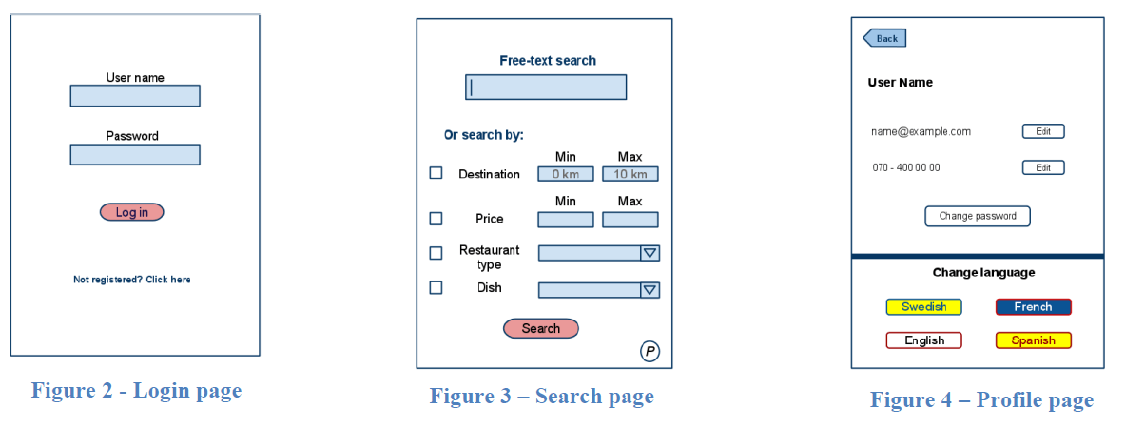

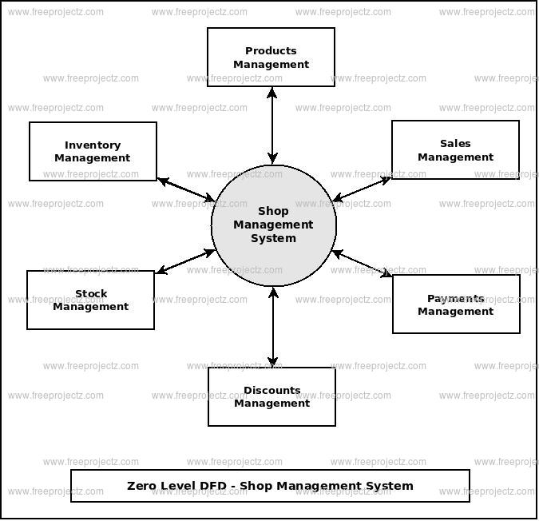

## Users and Characteristics

The software includes basic user requirements i.e. a very flexible GUI based system that makes it easy for users to use.

Users are Hardware Owner as Admin; Employees are as Data Enter, Accountant and Cashier

**Admin: -**

Many essential characteristics of a system administrator cover a wide spectrum of personal and professional traits. He is the single person who can access to every part of the system. The owner response for managing shop resources and employees, Invoice supply, product registrations, Stock management and GRN handling in this application.

**Data Enter: -**

In this application, The Data Entry Operator accesses to Product Registration and Supplier Registration only. The advantage of this application to this category is, even an out saucer can do this part. No need a temporary employee and it can be done when it is necessary only.

**Accountant: -**

An Accountant helps businesses make critical financial decisions by collecting, tracking, and correcting the company's finances. They are responsible for financial audits, and ensuring financial records are accurate. Under this application an accountant helps to goods purchasing and GRN handling, Out the invoices, supplier registration, stock management and cashier handling. But he is not allowed to user registration and products registration procedure.

**Cashier: -**

Cashier's **duties** include balancing the **cash** register, making change, recording purchases, processing returns and scanning items for sale.  According to this application, the cashier is allowed to only counter option. He does not have any access to any other part of this application

## Operating Environment

**Required Hardware: -**

* Pentium IV Processor above.
* 1GB above RAM.
* 20 GB Hard Disk space

**Required Software: -**

* windows 7 or above
* Microsoft .NET Frameworks 4.0 or above.
* Microsoft SQL Server Management Studio Express
* Java Development Kit

## Design and Implementation Constraints

To maintain the reliability and durability of the system, certain design and implementation limitations are applied. The system requires at least 512mb of memory. However, having 1GB of memory is recommended.

## User Documentation

System user documentation components, including user manuals, on-line assistance, and tutorials, that will be delivered with the software should be listed.

Actual formulations of any extensive user-manuals are not required but it is required to describe the types of manuals and the type of help required for the software. Overall, a brief paragraph of content will be sufficient to fulfil this particular section.>

## Assumptions and Dependencies

<List any assumptions that could have an impact on the requirements specified in the SRS. These generally include third-party and commercial components as well as issues pertaining to the development or operating environment. In addition to this, identify any dependencies the project has on external factors, including software components that will be reused from another project.

Provide a brief list or outline of the key assumptions that would have an influential impact on the system design.>

# Specific Requirements

## External Interface Requirements

### User Interfaces

### Hardware Interfaces

You need to have a specific computer to get the most out of the system. The system must be running on a system based on Microsoft Windows. Printing bills and records requires a laser printer.

### Software Interfaces

The computer on which you want to install this software must have the Windows operating system, Windows 7.0 or above, the .Net 4.0 installed on that Windows platform and the platform on which the software will run. With Microsoft SQL Server Management Studio Express Edition, an AD.NET data transmission is installed on the same computer.

## Functional Requirements

1. Registration - The User should be able to register with their details

1.1 The system should record following user details into user database.

Name, email, password, address

2. Log In

2.1 The system should verify the user username & password against the user database when logging in

2.2 After logging in, the member should be directed to the home screen of this system

3. Invoicing

3.1 The system should enable user to create new invoice to customers.

3.2 The system should display rate for all products.

3.3 The system should allow user to confirm or cancel invoice.

3.4 The system should record invoice details into database

4. Shop Owner Access

4.1 The system should generate financial and users, customers, suppliers reports for the shop manager

4.2 The system must enable full modification access for the Owner.

5 Payments

5.1 The system should allow user to pay bill via cash, card and check

## Behaviour Requirements

### Database View

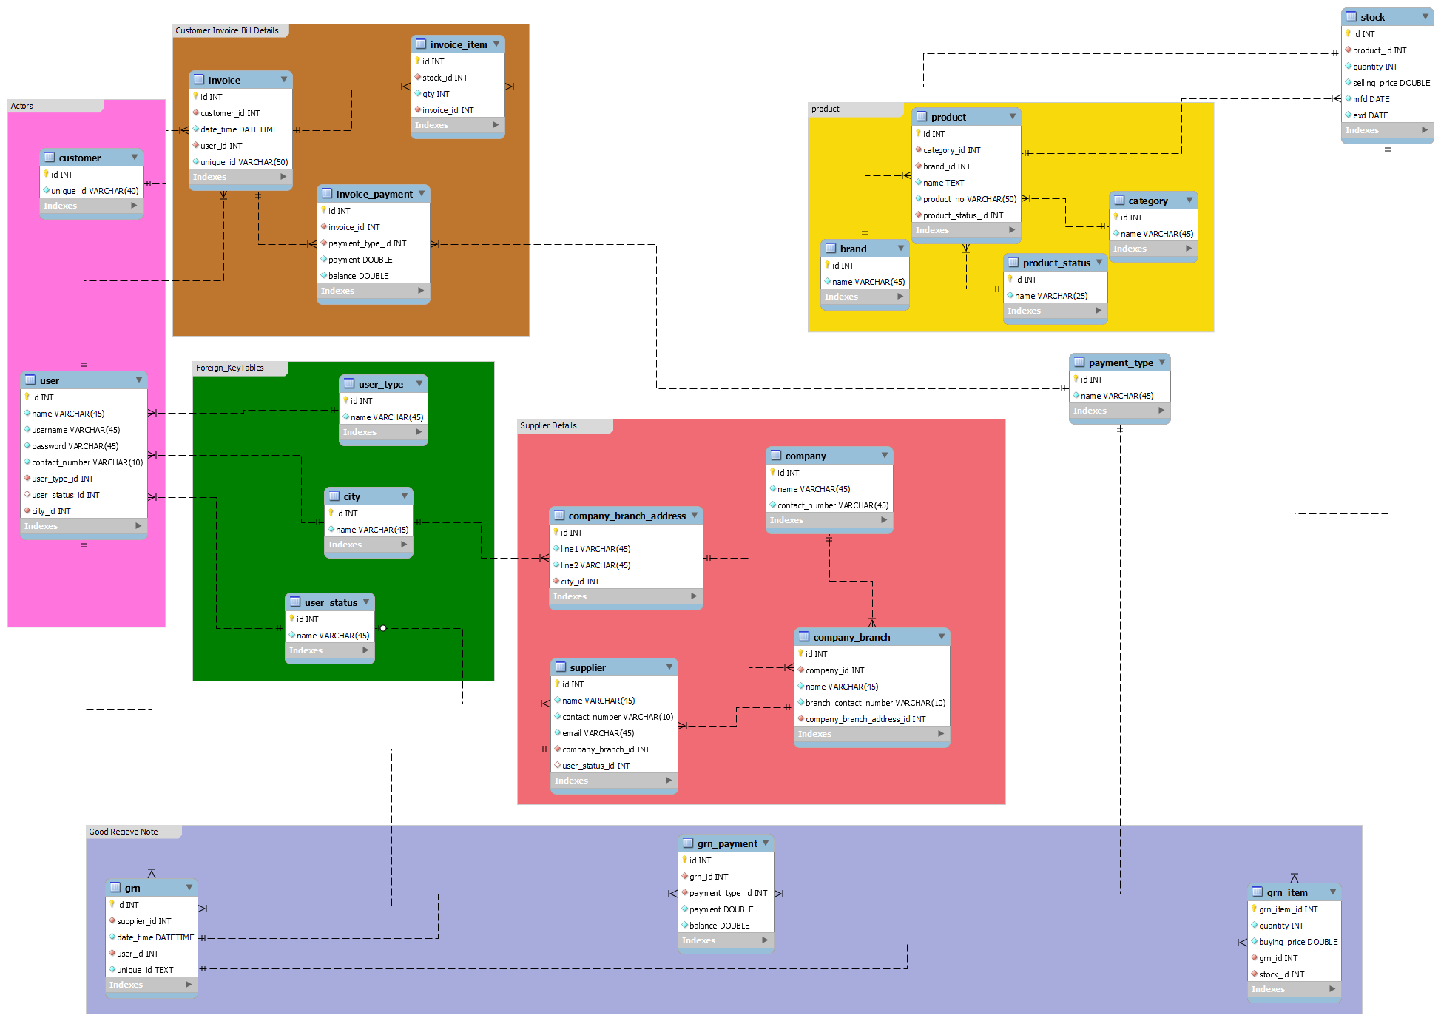

# Other Non-functional Requirements

## Performance Requirements

* Login Validation should be done within 2 seconds
* Data in database should be updated within 2 seconds
* Load time of UI Should not take more than 3 seconds
* Query results must return results within 3 seconds

## Safety and Security Requirements

The Hardware management system has several user levels, which are protected by a user login screen that requires a username and password to access various subsystems. This provides different views and accessible functions at the user level across the system. Backup maintenance ensures the security of the system database. This allows the system to be restored in the event of an emergency.

Database should be backed up every 30 minutes.

Under failure, system should be able to come back at normal operation under an hour.

Owner and users can log in to the Hardware management system. Users have goods received/invoicing access to subsystems. The Admin has the maximum privileges for all subsystems. A username screen that requires a username and password protects access to various subsystems.

All data must be stored, protected or protectively marked.

Appendix A - Group Log

<Specify all the group meeting minutes, group activities, and other relevant information that will assist the supervisor to determine the effort put forth to produce this document.>